Name:________________________________ Date:_______________ Group: ______

Purpose
Up to now you have considered situations where only a single force has acted on an object. But what if there is more than one force? For example, suppose two hockey players hit the puck at the same time. How should we treat the forces acting on the puck to understand its motion? In this homework you will use the I&M Simulator to investigate scientists’ ideas about how forces combine to affect the motion of objects.

How do objects behave when more than one force acts on them?

Initial Ideas
Imagine you had a cart with two fan units mounted on it, so that they push on the cart in opposite directions and with different strengths, as shown here.

Now suppose you held the cart stationary, turned both the fan units on, and then released it. What do you think would happen to the cart?

 What do you think would happen to the cart after you release it? Would it stay stationary, or would it move? If you think it would move, which direction would it go and what would happen to its speed (increase, decrease, or stay reasonably constant)? Explain your reasoning.

.

Now suppose that instead of just releasing the cart, you gave it a quick push so that it started moving to the left, in the same direction as the 1 N fan is pushing? How do you think the cart would behave after your push?

What do you think the motion of the cart would be like, just after your push? Would it keep moving to the left, at least for a while, or would something else happen immediately? Would its speed be increasing, decreasing or staying constant? Again, explain your reasoning

Collecting and Interpreting Evidence

Simulator Exploration #1. What effect do combinations of forces have on an object at rest?

In this exploration you will use the simulator model to examine scientists’ ideas about the effect that a combination of two forces has on an object that is initially at rest. You will also consider what strength a single force, acting on an otherwise identical cart, should have to produce the same effect.

STEP 1: Open the first simulator setup for this activity. The upper cart in the setup (Cart 1) has two fan units pushing on it in the same direction, with individual force strengths of 30 N and 20 N. A speed-time graph for this cart is shown on the lower left.   For now, focus only on Cart 1, which is initially at rest. How does it move when you run the simulator? (Speed up, slow down, or constant speed.) | 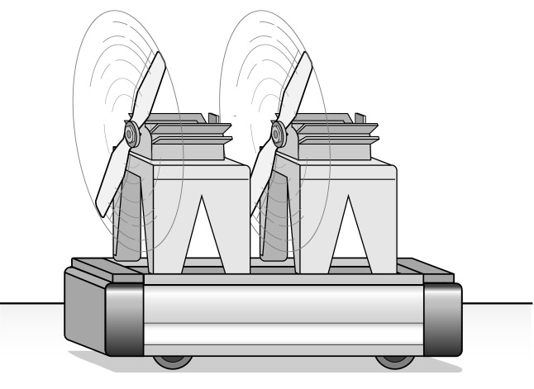  30 N  20 N  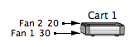

STEP 2: The lower cart in the setup (Cart 2) represents an identical cart (with the same total mass) but with only one fan unit, pushing with a force strength of 30 N. Its speed time graph is shown at the lower right. This cart is also initially at rest, but as the simulator was running you probably noticed that Cart 2 did not speed up as quickly, and so lagged behind Cart 1.  Suppose you wanted Cart 2 to move in exactly the same manner as Cart 1. (That is, you want them to remain side by side as they move along.) | 30 N  

If you could vary the strength of force with which the single fan unit on Cart 2 pushes, what value do you think it should have to make Cart 2 speed up in exactly the same manner as Cart 1, so that they stay side-by-side as they move? Briefly explain your reasoning. (Note: throughout this activity you should only think about adjusting the strength and/or direction of the single force on Cart 2, NOT adding any other forces.)

Rewind the simulator and adjust the strength of the single force acting on Cart 2 to the value you predicted above.

To change the strength of a force, first rewind the simulator. Then double-click on the head of the black force arrow itself to bring up the ‘properties box’ of the force. (If the ‘Properties of Background’ box appears, close it and try again.)

You can now change the strength of the force using the control at the top right. You can either adjust the value using the slider control, or type in a new value

After adjusting the strength of the force on Cart 2, run the simulator again.

Do the carts speed up in the same manner now? (If so, they will stay side-by side as they move.) Why do you think this is? (If they don’t move together, return to the simulator and adjust the strength of the fan on Cart 2 until they do. Then comment briefly on your findings here.)

STEP 3: Now, rewind the simulator, and remove the 20 N force (Fan 2) from Cart 1. Then add a new 20 N force pushing to the left.

To remove a force, first use the selection tool to select the force arrow. Once the force is selected, just hit the ‘Delete’ or ‘Backspace’ key on your keyboard

To add a force to the cart, first click on the ‘Pushing force’ tool in the tool bar.  Next, click on the object and, holding the mouse button down, drag out a force arrow to the right of the cart. The value of its strength will increase as you drag.  If you do not get the right value for the strength, you can change its value as outlined in STEP 2 above. |   

This new set-up for Cart 1 represents an arrangement similar to the one in the Initial Ideas section. (Two fan units, pushing in opposite directions with different force strengths.). The fan unit pushing to the right is stronger than that pushing to the left.  Before running the simulator consider the following questions. | 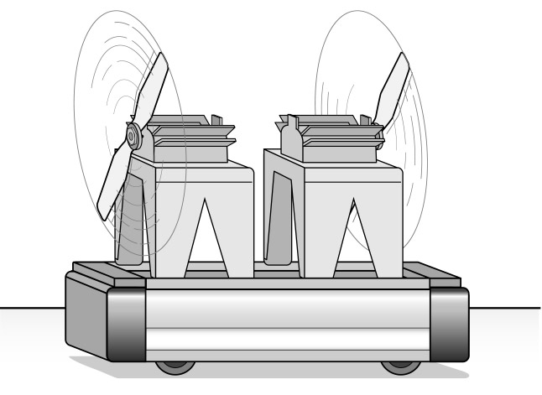  30 N  20 N  

How do you think Cart 1 will move now, if at all, after being released? (Not move, speed up, slow down, or constant speed.) Explain your reasoning.

Do you think the weaker 20 N force will have any effect on the motion of the cart, or will it behave in exactly the same way as if only the 30 N force were acting on it? Explain your thinking.

What value do you think the strength of the single force on Cart 2 should have now, so that its motion will match that of Cart 1 with the two opposing forces? Again, explain your reasoning.

Adjust the strength of the single force on Cart 2 to the value you suggested above and then run the simulation.
Does Cart 1 behave in the way you predicted?

Does the motion of Cart 2 match that of Cart 1? (If not, return to the simulator and adjust the strength of the fan on Cart 2 until it does. Then comment on your findings here.)

Unbalanced Combinations of Forces
When more than one force acts on an object, the effect they cause is due to the combination of all the forces together. When the total strength of all the forces acting in one direction is bigger than the total strength in the opposite direction (as shown below) we say that the forces are unbalanced.

(When the total strength of all the forces pushing one way is exactly the same as the total strength pushing in the opposite direction, we say that the forces on the object are balanced. You will examine the effect of a balanced combination of forces on an object in a later activity.)

In the first part of this activity you examined the effect that an unbalanced combination of forces has on an object that is initially at rest.

 When unbalanced forces act on an object that is initially at rest, what effect does the simulator model suggest they have on it? After it has started moving, does its speed increase, decrease, or remain constant?

Does the simulator model suggest that a single force can have the same effect on a stationary object as an unbalanced combination of forces? If so, describe how you would calculate the strength of that single force.

Simulator Exploration #2: What effect does an unbalanced combination of forces have on an object that is already moving?

In this second experiment you will use the simulator model to examine scientists’ ideas about the effect that an unbalanced combination of two forces has on an object that is already moving. (How the object started moving is not important here, just that it is already moving.)

STEP 1: Open the second simulator setup for this activity. It is very similar to the setup in STEP 3 of Exploration #1, except that at the moment the simulator starts Cart 1 is already moving to the right at a certain speed, as shown by the speed arrow. | 20 N  30 N  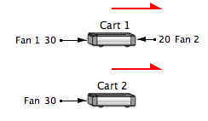
When the simulator is run, what effect do you think this unbalanced combination of forces will have on the motion of Cart 1? Will it slow down speed up, or move at a constant speed? Explain why you think so.

Now run the simulator. What is the motion of Cart 1 like? (Speed up, slow down, or constant speed.) Is this what you predicted above?

In this setup Cart 2 starts out moving to the right at the same speed as Cart 1, as shown by the equal length speed arrows at the start.

What value do you think the force strength of the single fan unit on Cart 2 should have to make the two carts move side-by-side? Explain your reasoning.

Check your idea using the simulator and record the result below.

STEP 2: Now suppose you changed the force strength of the two fan units on Cart 1, so that the force acting opposite to the direction of motion was stronger than the force in the same direction as the motion, as shown to the right. | 20 N  30 N  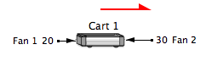
What effect do you think this unbalanced combination of forces will have on the motion of Cart 1? Do you think it will continue moving to the right and speed up, slow down or move at a constant speed, or would something else happen? Explain your thinking.

What do you think you would have to do to the direction and strength of the single force acting on Cart 2 to make the two carts continue to move side-by-side? Explain your reasoning.

Again, check your ideas using the simulator and record the results below.

Suppose the simulator were to run for several seconds longer. What do you think would happen to the carts? Explain your thinking.

Rewind the simulator, then set it to run for 20 seconds instead of 10 seconds.

To extend the running time of the simulator double-click on the white background of the simulator window to bring up the ‘Properties of Background’ box.  You can now change the length of time the simulator runs using the control on the middle left. | 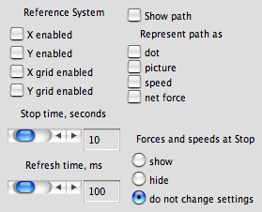

Now run the simulator again. Do the carts behave as you predicted?

STEP 4: Use your results from this simulator exploration to answer the following questions.

If an object is already moving, what effect (if any) does the simulator model suggest an unbalanced combination of forces has on its speed? Does the speed change, or does it remain constant?

What happens to the speed of a moving object if the force acting in the same direction as its motion is stronger than the force acting in the direction opposite its motion?

What if the stronger force acts in the direction opposite to the motion?

Net Force
You have seen in this activity that when an unbalanced combination of forces acts on an object, you can also find a single force that would make the object move in the same manner. Further, you have seen that the strength and direction of this single equivalent force can be found by adding and/or subtracting the strengths of the individual forces, depending on the direction in which they act. Scientists call the result of such a calculation the net force acting on the object. For example, consider the box below. The total force pushing to the right is 700 N, while the force pushing to the left is 500 N. Thus the net force on the box would be 200 N pushing to the right.

Unbalanced combination of forces
Net force

Summarizing Questions
S1: When an unbalanced combination of forces acts on an object (either at rest or in motion), does the speed of the object change, or does it remain constant? Is this the same as, or different from, the effect of a single force? Why does this make sense?

S2: In a previous class a student made the following statement:

“When more than one force acts on an object only the strongest force matters. It’s as if the weaker forces were not there and the object moves the same as if only the strongest force were acting on it.”

Do you agree or disagree with this student? What evidence from this activity supports your thinking?

S3: Four people push on a large box with the forces shown in the diagram below.

What is the net force (strength and direction) acting on the box? Explain how you determined your answer.

S4: In the Initial Ideas section of this homework activity you were asked about the motion of a cart with two fan units of unequal strength attached. Students in a previous class performed this experiment and noticed that, after their initial push, the cart slowed down gradually.

The students were not sure which of the two fans was the stronger, but one of them wrote the following explanation for why the cart slowed down.

Explanation: Why did the cart with two opposing fans on it slow down after being given an initial push?

Describe the Situation using a diagram:

Write the narrative:

The initial push gets the cart started moving to the right, but after the hand loses contact the only forces acting on the cart are from the two fan units. When a weaker force opposes a stronger force, an object will move in the direction of the stronger force, but will slow down as it does so. Because Fan #1 is the stronger force, and is pushing in the same direction as the motion, the cart keeps moving to the right. However, Fan #2 exerts a weaker force in the direction opposite the motion, so the cart slows down.

Evaluate this Explanation:

Decide whether this explanation (including both the force diagram and narrative) is good or poor by reviewing each of the following criteria.

Present | Criterion
YES/NO | Completeness: All ideas needed are included
YES/NO | Accuracy: All ideas included correspond to established ideas
YES/NO | Logical Reasoning and clarity: Narrative connects ideas to the phenomenon, and is well written.

If you find this explanation to be good, give your reasons below. If you find it to be poor, again give your reasons and also correct it.

